Sprint 5 Mini ERD
Multiple Check-ins, Friend Footprints, Event Lists, Public Check-ins, and Participant Profile Navigation

Model boundary: Sprint 5 reuses the Sprint 4 entities shown in the supplied ERD. The increment is expressed through query paths, cardinality, visibility and uniqueness rules; no unnecessary standalone entity is introduced.

Sprint 5 ERD Diagram
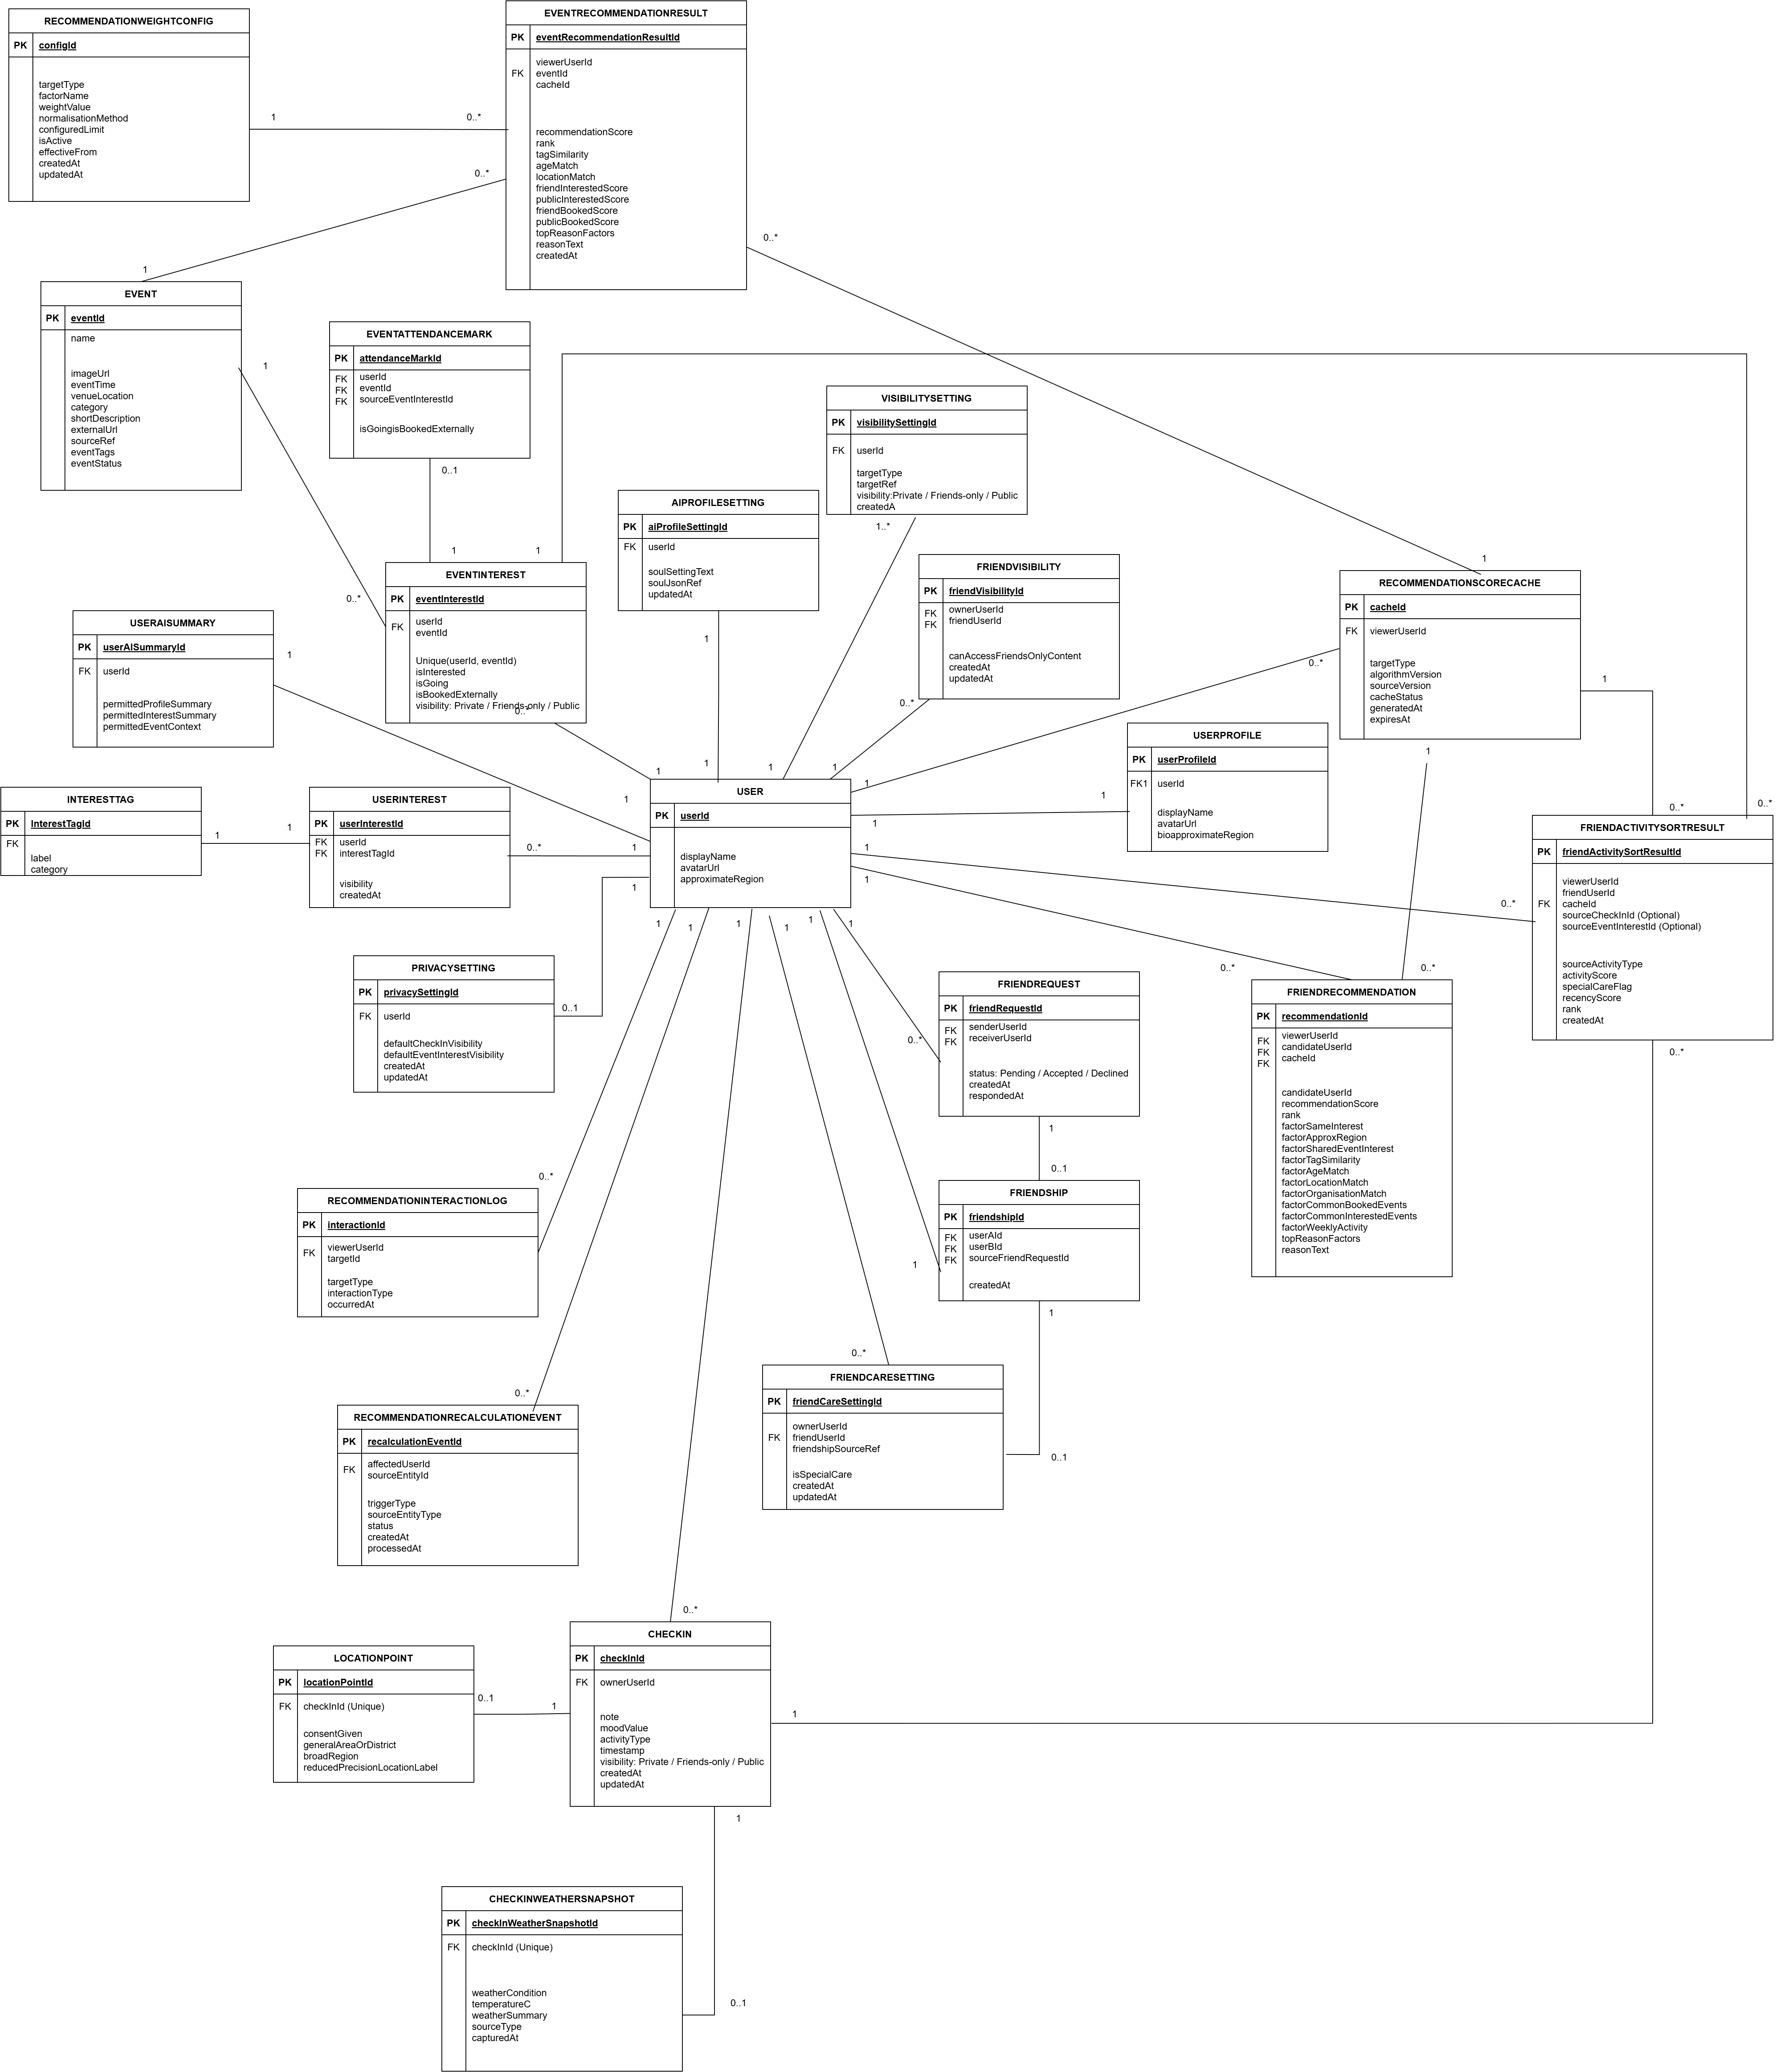
Figure 1. Sprint 5 ERD — retained Sprint 4 entity model with Sprint 5 query and visibility rules

1. Sprint 4 vs Sprint 5 Change Summary
Comparison item | Added or modified in Sprint 5 | Removed / unchanged / out of scope
Check-in behaviour | Explicitly supports multiple CheckIn records for the same user on the same calendar day. Each record remains independently timestamped and visible. | No daily uniqueness constraint; no daily summary entity; existing location and weather snapshot relations remain optional.
Social footprint discovery | Adds friend-footprint and public Check-in query paths using Friendship/FriendVisibility plus CheckIn.visibility. | No separate FriendFootprint entity and no access to Private records.
Event activity | Defines Interested Events and Booked Events as filtered views of EventInterest and EventAttendanceMark. | No duplicate InterestedEvent or BookedEvent entity; external booking remains a manual mark, not booking verification.
Participant navigation | Defines Event → EventInterest → User → UserProfile navigation for opening a participant Profile. | No direct Event-to-UserProfile foreign key and no exposure that bypasses VisibilitySetting.
Recommendation subsystem | Retained from Sprint 4 and may consume public/friend-authorised activity only where allowed. | No new ranking formula or scoring entity is introduced by the Sprint 5 requirements.

2. Sprint 5 Functional-to-Data Mapping
Sprint 5 function | Primary entity path | Required data rule | Expected result
Multiple Check-ins on the same day | User 1 → 0..* CheckIn | checkInId is unique; ownerUserId + calendar date is not unique. Sort by timestamp/createdAt. | A user can create and retrieve several separate Check-ins during one day.
Friend footprints | User → Friendship/FriendVisibility → CheckIn → LocationPoint | Return Friends-only records only for an authorised friendship; Public records may also appear. LocationPoint remains reduced precision. | A user sees permitted recent Check-ins from friends without exposing Private locations.
Interested Events | User → EventInterest → Event | Filter EventInterest.isInterested = true. One EventInterest row per userId + eventId. | The user's interested-event list is derived consistently from existing marks.
Booked Events | User → EventInterest/EventAttendanceMark → Event | Filter isBookedExternally = true or the mirrored external-booking attendance mark. | The user sees events manually marked as booked externally; this is not booking confirmation.
Public Check-ins | CheckIn → User/UserProfile; optional LocationPoint | Filter CheckIn.visibility = Public. Apply reduced-precision location and Profile visibility. | Public Check-ins can be discovered without revealing private or precise location data.
Participant to Profile | Event → EventInterest → User → UserProfile | Participant membership requires isGoing = true or the approved participant-state rule; profile fields are filtered by VisibilitySetting. | Selecting a visible participant opens that user's permitted Profile.

3. Sprint 5 Relevant Entity Summary
Entity | PK | Sprint 5 relevant fields | Sprint 5 role
User | userId | displayName; avatarUrl; approximateRegion | Root reference for Check-ins, event activity and Profile navigation.
UserProfile | userProfileId | userId; displayName; avatarUrl; bioApproximateRegion | Target of participant-to-Profile navigation.
VisibilitySetting | visibilitySettingId | userId; targetType; targetRef; visibility | Controls which Profile fields or targets are visible.
PrivacySetting | privacySettingId | userId; defaultCheckInVisibility; defaultEventInterestVisibility | Stores user-level default visibility preferences.
Friendship | friendshipId | userAId; userBId; sourceFriendRequestId | Confirms the friend relationship used by friend-footprint access.
FriendVisibility | friendVisibilityId | ownerUserId; friendUserId; canAccessFriendsOnlyContent | Authorises Friends-only content without replacing CheckIn.visibility.
CheckIn | checkInId | ownerUserId; note; moodValue; activityType; timestamp; visibility | Stores every Check-in separately; permits multiple records per day.
LocationPoint | locationPointId | checkInId (Unique); consentGiven; generalAreaOrDistrict; broadRegion; reducedPrecisionLocationLabel | Optional reduced-precision location for a Check-in.
CheckInWeatherSnapshot | checkInWeatherSnapshotId | checkInId (Unique); weatherCondition; temperatureC; weatherSummary | Optional captured weather context retained from Sprint 4.
Event | eventId | name; eventTime; venueLocation; category; sourceRef | Event record used by interested, going and booked lists.
EventInterest | eventInterestId | userId; eventId; isInterested; isGoing; isBookedExternally; visibility | One row per user and event; supports Sprint 5 event lists and participant navigation.
EventAttendanceMark | attendanceMarkId | userId; eventId; sourceEventInterestId; isGoing; isBookedExternally | Prototype mirror for filtering; does not verify actual attendance or booking.

4. Relationship and Cardinality Rules
- User 1 : 0..* CheckIn. Multiple rows may share the same owner and calendar day; each row has its own checkInId and timestamp.
- CheckIn 1 : 0..1 LocationPoint and CheckIn 1 : 0..1 CheckInWeatherSnapshot.
- User many-to-many User through Friendship; FriendVisibility stores the authorised Friends-only access pair.
- User 1 : 0..* EventInterest and Event 1 : 0..* EventInterest; (userId, eventId) is unique.
- EventInterest 1 : 0..1 EventAttendanceMark when the prototype materialises an event participation mark.
- User 1 : 1 UserProfile. Event participants reach the Profile through EventInterest.userId, not through a direct Event foreign key.
- VisibilitySetting and content-level visibility are evaluated before returning Profile, Check-in or event-activity data.

5. Constraints and Query Rules
Rule ID | Constraint / query rule | Rationale
S5-ERD-01 | Do not create a unique constraint on (ownerUserId, calendarDate) for CheckIn. | The requirement explicitly allows multiple Check-ins on one day.
S5-ERD-02 | Friend-footprint queries require an active friendship plus content visibility of Friends-only or Public. | Prevents Private Check-ins from leaking through social discovery.
S5-ERD-03 | LocationPoint data returned to other users must remain reduced precision and consent-based. | Preserves the privacy boundary inherited from Sprint 2.
S5-ERD-04 | Interested Events use isInterested; Booked Events use isBookedExternally; both are derived from EventInterest. | Avoids duplicate entities and inconsistent event lists.
S5-ERD-05 | Event participant navigation uses EventInterest.userId → User → UserProfile. | Keeps the relationship normalised and traceable.
S5-ERD-06 | Profile fields must be filtered by VisibilitySetting before display. | A participant list does not grant unrestricted Profile access.
S5-ERD-07 | Public Check-in discovery filters visibility = Public and must not infer precise coordinates. | Supports public discovery without weakening location privacy.

6. Scope Boundaries and Assumptions
- Sprint 5 does not introduce live location sharing, continuous tracking, map coordinates, route history or background tracking.
- Friend footprints are authorised Check-in records, not a permanent movement history.
- Booked externally remains a user-entered mark; no payment, ticket verification, refund or attendance confirmation is implied.
- A visible participant may open a Profile only when the relevant Profile fields are permitted.
- Recommendation caches, scores and AI logs remain Sprint 4 backend concerns and are not expanded by this Sprint 5 ERD.

